Created a playbook :

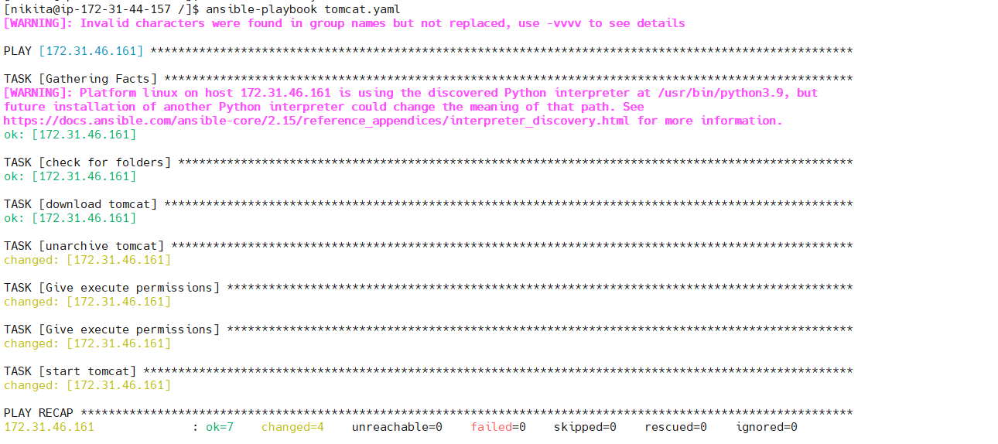

There are two instances:

Added 8080 to security group of Host:

Tomcat deployed:

